1. Northstar Retail Group Information
Requestor: | Jordan Lee, Director of Customer Experience | TPA Assessor: | Morgan Chen, Third-Party Risk Analyst
Report Date: | September 9, 2026 | TPA Reviewer: | Riley Brooks, GRC Manager
Department: | Customer Experience | Assessment Period: | August 24 - September 8, 2026
Other Distribution: | Priya Shah, Alex Romero, Casey Morgan

2. Third-Party Information
Third Party Company: | CloudHarbor Systems
Applicable vendor service: | SupportHub customer service platform
Sub-vendor Name: | Northwind Cloud Services
Applicable vendor service: | Cloud hosting and managed database

3. Assessment and Solution Details
Type | Contract reviewed | Compliance | Product/Services
SaaS | Included in scope  this review | SOC 2 Type II; ISO 27001 | Customer support platform
TPA ID: | TPA-2026-014 | Project Name: | SupportHub implementation
Data Classification: | Confidential - customer PII |  | Service Criticality (Impact): | High
Assessment Conclusion
The assessment supports proceeding with conditions for the SupportHub use case described in this fictional demonstration.

Assessment outcome*
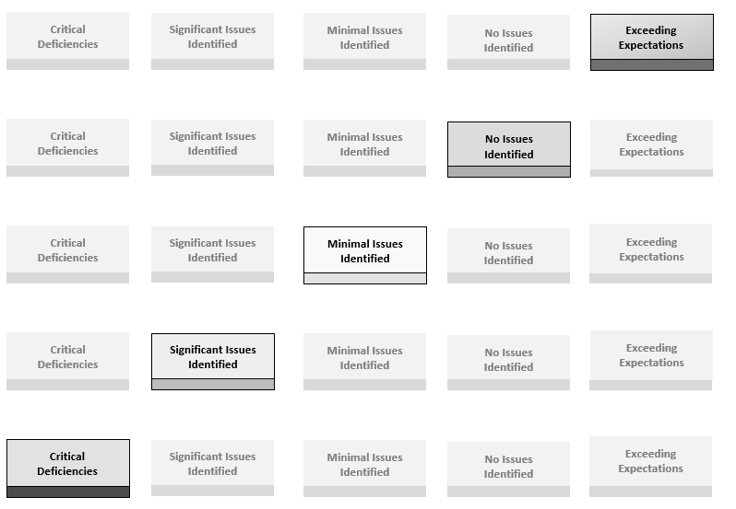
* Minimal issues identified. Final approval depends on completing the implementation and provider actions below.

A material change to the service, data, access, integration, hosting location, subcontractors, or business use requires a new third-party review.
Action Items for Implementation Team
Actions to complete before production use:
1. Enable single sign-on, multifactor authentication, and automated user deprovisioning before go-live.
2. Complete architecture and legal review; verify the data-processing terms, retention schedule, and tested data-export process.
Action Items for Vendor
1. Provide evidence that the two medium-severity penetration-test findings were remediated.
2. Confirm the 24-hour incident-notification commitment and provide the current subcontractor and data-residency list.
Solution Overview
This fictional report documents the controls CloudHarbor Systems presented for the SupportHub service and the evidence reviewed for Northstar Retail Group's intended use. The conclusion applies only to the scope recorded here.

CloudHarbor Systems provides a cloud-based customer support and case-management platform.

Northstar Retail Group will use SupportHub to manage customer questions, returns, and service escalations.

SupportHub will receive customer names, email addresses, order references, support messages, and service history. It will not store payment-card data.

4. Other Assessment Details
Assessment Details:

CloudHarbor Systems reported the following security controls:
- Independent SOC 2 Type II and ISO 27001 coverage; documented vulnerability management; centralized logging; annual incident-response exercises; role-based access.

CloudHarbor Systems reported the following encryption standards:
- Data in transit - TLS 1.2 or later
- Data at rest - AES-256
- Key management - cloud key-management service with restricted administrative access
- Backups - encrypted, geographically separated, and retained for 35 days
- Administrative access - private access path with multifactor authentication

CloudHarbor Systems reported the following physical-security arrangement:
- Production infrastructure is hosted by Northwind Cloud Services. CloudHarbor personnel do not administer physical data-center controls.

CloudHarbor Systems reported the following access controls:
- Single sign-on is supported; privileged roles require multifactor authentication; access is reviewed quarterly; administrative activity is logged.

CloudHarbor Systems maintains documented recovery procedures and tests them annually. The most recent test met the stated eight-hour recovery-time objective and four-hour recovery-point objective. The test did not include a complete regional failure, so Northstar will track that limitation during ongoing monitoring.
Data Flow High-Level Diagram
Customer and order references flow from Northstar applications through an approved API to SupportHub. SupportHub stores support records in Northwind Cloud Services. Authentication is federated through Northstar's identity provider.
Documentation Reviewed:

The assessor reviewed the following fictional demonstration evidence:
SOC 2 Type II report covering January 1 - December 31, 2025; ISO 27001 certificate; penetration-test summary dated June 2026; incident-response plan; business-continuity test summary; data-flow diagram; subcontractor list; completed security questionnaire.

